Lorain County Detention Utilization Report: 2018-2021

Lorain County domestic relations court – juvenile division | 225 Court St, Elyria, Ohio

Giovanna Reising, Lorain county quality assurance manager

2022

Table of Contents

Introduction 2

Part One: The Detention Risk Assessment Instrument 2

Changes to the Risk Assessment Instrument 2

RAI Screening Results 4

The Quarterly Reporting Sheet and RAI 5

Part Two: Detention Admissions 12

Reasons for Admission 12

Initial Offense Admissions 13

Admissions by Race/Ethnicity 15

Admissions by Gender 17

Individual Youth Detainment 17

Unique Detainments by Race/Ethnicity 18

Part Three: Average Daily Population 19

Gender 19

Race/Ethnicity 21

Part Four: Average Length of Stay 22

ALOS by Race/Gender 23

ALOS by Other Detainment Reason 25

Part Five: Alternative to Detention Program/Pre-Disposition Services 27

Program Referrals 27

Average Length of Stay in PDS 28

Conclusion 29

Recommendations 29

## Introduction

In 2019, The Annie E. Casey Foundation, in partnership with the Ohio Department of Youth Services, accepted Lorain County Domestic Relations Court’s application to participate in Juvenile Detention Alternatives Initiative (JDAI). Lorain County sought this partnership as a way to improve many facets of juvenile justice practice, including detention utilization, community supervision, data collection and analysis, and better overall service to court-involved youth and families. One of JDAI’s prime objectives is to decrease the number of youth unnecessarily or inappropriately detained without sacrificing community safety. This report will illustrate the impacts of JDAI-led changes in the Lorain County’s juvenile justice practice and detainment decision-making, as well as areas of focus for future growth.

## Part One: The Detention Risk Assessment Instrument

## Changes to the Risk Assessment Instrument

One of JDAI’s eight core strategies is to “[utilize] objec­tive admis­sions cri­te­ria and screen­ing instru­ments to replace sub­jec­tive deci­sion-mak­ing processes”. As such, a review of the intake process is key to ensuring that only appropriate youth were being screened in for detainment.

The Lorain County Detention Home uses a risk assessment tool to determine if an arrested youth should be detained. The first-generation Risk Assessment Instrument (RAI) had been in use for approximately fifteen years. The creation of the RAI was a collaborative effort by court staff and community partners, which included police and prosecutors, to ensure the RAI was appropriately and consistently recommending detainment or release based on the youth’s risk to community safety. The first-generation RAI scored the youth based on their presenting offense as well as any active and prior offenses. Any RAI scoring an “8” or higher resulted in detainment. Felonies were scored higher than misdemeanors; offenses that were violent and any offense including a weapon were given additional points. For example, a homicide offense would always result in a detainment (score of 12) as did any offense involving a firearm (the original offense score plus 8 points). In certain cases, however, the tool’s score structure lead to “stacking of points”. This could negatively impact the youth’s release process as the initial RAI score was included in a later Detention Review Tool.

The Detention Review Tool guides decision-making and recommendations for release after a thorough review of the youth’s case history, community status, and current behavior. Every detained youth subject to release is reviewed regularly by Probation and other Court leadership. The screening tool includes the youth’s initial RAI score (risk level) and subtracts any protective measures for community placement. The tool also takes into consideration the youth’s behavior, risks present in the community (e.g. lack of available supervision, history of absconding, lack of services in place), and educational/employment status. The youth can have their score increase if their social history and lack of community stability put them at risk for recidivism.

In 2021, the RAI was reviewed and amended by Probation and Detention leadership as well as community stakeholders [e.g. educators, law enforcement, mental health providers, youth service providers, child protective services, community support service providers]. Taking the subsequent impact of a “stacked score” into consideration, probation and detention leadership as well as community partners worked collaboratively to improve the screening process for officers and court staff requesting that a youth be detained. Reviewing a youth’s Court history can be complicated and take up valuable time of not only arresting officers, but of the Detention employees. In order to streamline the process, the team listed several situations by which a youth would be considered an “auto-hold” and their RAI score could be completed at a later time[1]. The list is as follows:

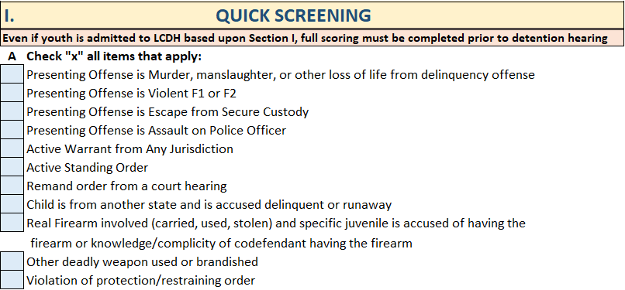

Figure 1: Quick Screening Tool Included in the RAI

Also included in the Quick Screening area is a section of mitigating factors for an auto-hold. If any of these factors are present, the youth’s case is reviewed further by Detention staff:

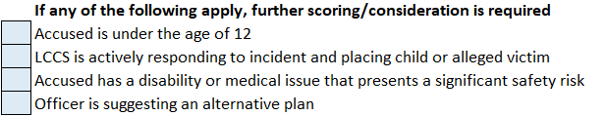

Figure 2: Section 2 of the RAI Quick Screening Tool

## RAI Screening Results

Based on the 2021 Admissions, most youth who were detained fell under one or more of the Quick Screening auto-hold criteria. The RAI is fully scored at a later time and recorded in the QRS. The Quick Screen Auto-hold allows the DH worker to expedite the intake process for most youth.

|  |  |
| --- | --- |
| **2021 Admission Auto-hold Reason** | **Count** |
| **Standing Orders** | **52** |
| **Warrant** | **45** |
| **Weapons Involved** | **35** |
| **Sentence** | **14** |
| **Remand** | **12** |
| **Violent F1/F2** | **11** |
| **Assault on Police Officer** | **6** |
| **Other/Blank** | **2** |
| **Out of State Runaway** | **1** |
| **All Auto-hold Total** | **178** |
| **No Auto-hold Detainment** | **67** |
| **Total Detainments** | **245** |

Figure 3: 2021 Detention Auto-hold Reasons

Figure 4: 2021 Auto-hold Chart

In 2021, there were 245 admissions to the Detention Home. 178 detainments were under one or more of the “auto-hold” definitions (72.7%) [These categories vary slightly from the QRS auto-hold definitions, see Figure 7]. The remaining detainments were either held due to an eight or higher cumulative score (n=38, 15.5%) or assigned an override reason for detainment (n=29, 11.8%).

|  |  |
| --- | --- |
| **2021 Non-Auto-hold Admissions** | **Count** |
| **Non-violent Felony but Major Public Safety Concern** | **4** |
| **Safety Concerns (Arresting Officer)** | **11** |
| **Violent Offense with Victim Access** | **14** |
| **Held Due to Score of 8 or Higher** | **38** |
| **Total** | **67** |

Figure 5: 2021 Admissions with no Automatic Hold Category

2021 examples of non-violent public safety concerns are Grand Theft Motor Vehicle involving a high speed chase, Inducing Panic, and Aggravated Menacing. Examples of violent offense with victim access are sexual assault cases where the youth has access to the victim(s), domestic violence cases where shelter or respite is not an option/not available, misdemeanor riot or misdemeanor assault. Examples of officer safety concerns are violent behavior with medication non-compliance, on-going threatening behavior, on-going domestic violence behavior, and out-of-state youth committing offenses in Lorain County with no immediate release options.

The following chart illustrates that the majority of youth in 2021 were held due to either an auto-hold or that their case history and presenting offense resulted in a score of 8 or higher, which meets the threshold for detainment. Eight percent of the remaining detainments involved safety concerns.

Figure 6: 2021 Admission Types by Percentage

## The Quarterly Reporting Sheet and RAI

JDAI participation requires data analysis through a Quarterly Reporting Sheet (QRS) format, structured by JDAI. The QRS allows for comparative analysis of demographic and offense data as well as detailed average daily population and average length of stay for detained youth. Once Lorain County updated and formalized their RAI process in 2021, the score, override reason, auto-hold status, and auto-hold reason were entered into the QRS.

There are youth who are screened for detainment but who nevertheless are not detained. Police Departments contact the Detention Home and a DH worker screens the youth with the RAI. If the youth falls between a score of 0 to 7, the youth is recommended to be referred to either the Turning Point Shelter, the Assessment Center (AC), or released to parent/caregiver. Turning Point Shelter (TPS) can also house youth who have no underlying criminal activity (e.g. Child Protective Services respite requests, runaways); the RAI has been modified to include what the referent is requesting (DH vs. Turning Point). Any youth being placed at Turning Point who were not initially Detention referrals are not counted in this data, but are scored regardless for local data purposes.

The QRS requests that youth who are released be tracked as well; according to their definitions, youth who are referred to TPS or AC are “released with conditions” and youth who are released to parent/caregiver be labeled “released”. These two parameters should also have scoring thresholds; the RAI team set the “released with conditions” score to fall within 4-7 and the released to parent at 0-3.

What this evaluator found when uploading the data on releases was that many of the youth who scored a “3” for a misdemeanor domestic violence were referred for placement at TPS. These edge cases accounted for most of the youth who were “overridden up” by giving the youth conditions with their release. After modifying the thresholds on the QRS to include a score of 3 as a base for conditioned releases, the outliers for overrides were more accurately reflected. It is a recommendation of this evaluator that either the threshold for TPS referral be lowered to a “3” or that misdemeanor violent offenses be scored higher at a “4”.

The following charts disaggregate 2021 RAI information as it is interpreted by the QRS. The definitions of overrides up and down are provided in the text boxes.

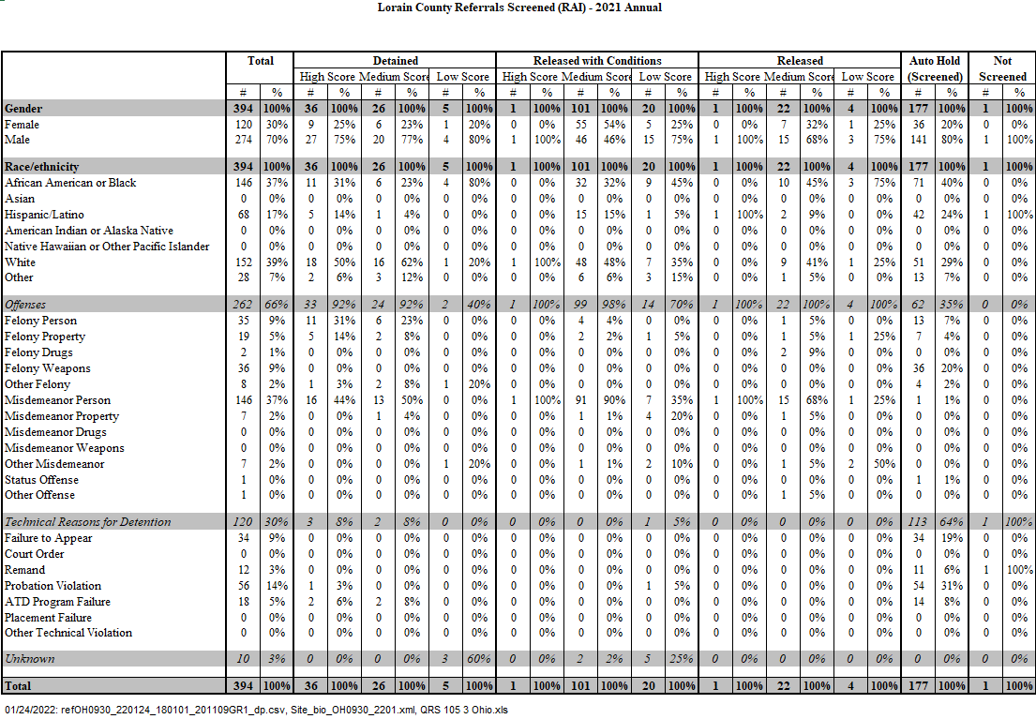

Figure 7: 2021 Lorain County Screened Referrals RAI

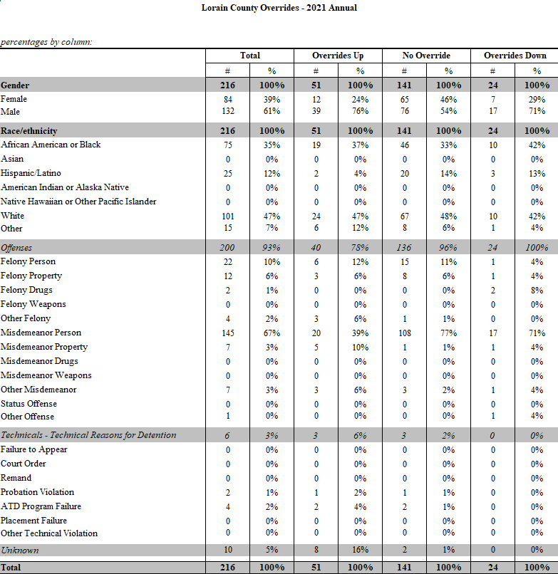

**Report Indicators: Overrides Up**

**Definition:** A count of youth screened during the reporting period who were not subject to an Auto-hold and whose intake decision was more restrictive than their RAI scores would have suggested. Includes youth whose risk assessment scores were below the site’s threshold for placement in secure detention, but who were nevertheless placed in secure detention; as well as youth whose scores were below the site’s threshold for release with conditions, but who were nevertheless released with conditions or detained.

**Type of Aggregation**: Count

**What to aggregate:** Referrals

**Calculation Conditions:** Satisfies conditions for both Detained and Medium Score; or satisfies conditions for both Detained and Low Score; or satisfies conditions for both Released with Conditions and Low Score (see RAI)

**Fields Referenced:** Intake decision, RAI score, Intake date, Auto_hold

Figure 8: 2021 RAI Overrides: Percentages by Column

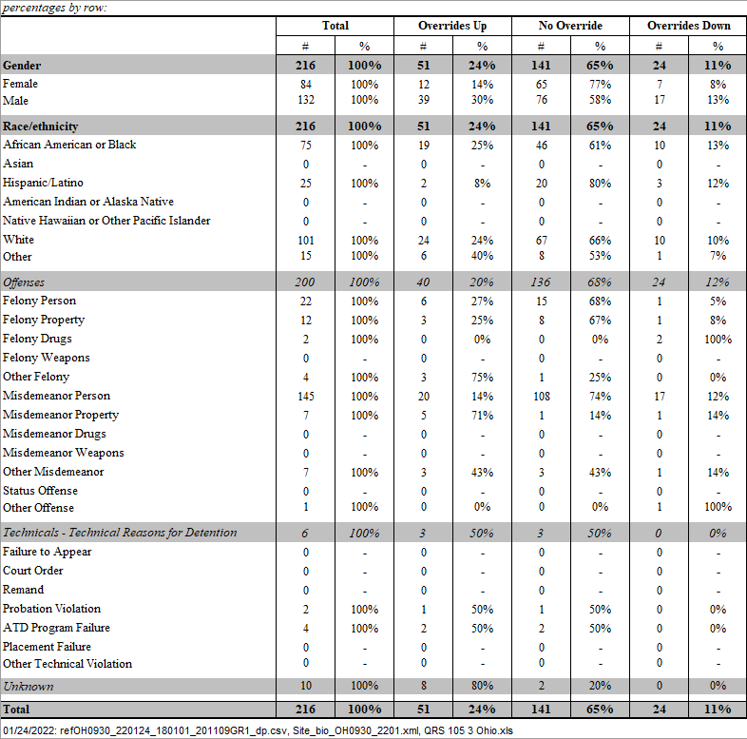

**Report Indicators**: **No Override**

A count of youth screened during the reporting period who were not subject to an Auto-hold and whose intake decision is consistent with their score on the RAI. That is, if the risk assessment score is high, the decision is to detain; if the risk assessment score is medium, the decision is to release with conditions; and if the risk assessment score is low, the decision is to release outright.

**Report Indicators: Overrides Down**

A count of youth screened during the reporting period who were not subject to an Auto-hold and whose intake decision was less restrictive than their RAI scores would have suggested. Includes youth whose RAI scores are above the site’s threshold for placement in secure detention, but who are nevertheless released (outright or with conditions); and those whose scores are above the threshold for release with conditions, but who are nevertheless released outright.

Figure 9: 2021 RAI Overrides, Percentages by Row

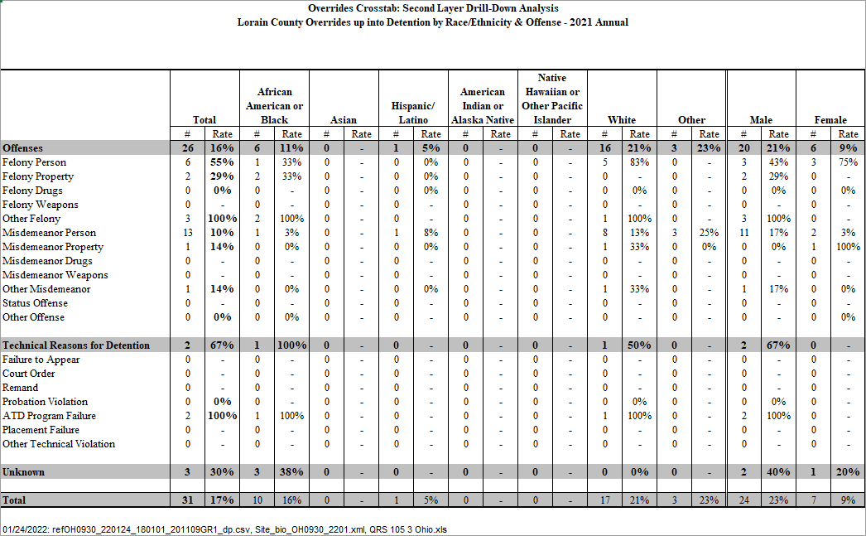

This last chart pulls out only the youth who were overridden up into the Detention Home (31 youth, 17% of non-auto-hold youth with scores less than 8). One youth was Hispanic/Latino, 10 youth were Black, 17 youth were white, and 3 youth were Mixed Race (Other). Fifteen of these youth had Misdemeanor referral reason (13 violent/person) and eleven youth came in with felonies that did not fall under any auto-hold category.

Figure 10: 2021 Detainment Overrides Up to Detainment

Figure 11: 2021 Overrides Up to Detainments by Race/Ethnicity

Based on the referrals to the Detention Home for 2021, there does not appear to be any consistent increase in overrides up based on race/ethnicity. White youth’s score was overridden up at a rate much higher than their admissions percentage (55% vs 35%). Hispanic youth were overridden up at a much lower rate than their admissions population (3% vs 20%). Black youth were overridden lower than their overall admissions percentage (6% difference), Mixed Race youth were overridden higher than their admissions percentage (3% difference).

Because the RAI was modified in 2021, Lorain County is unable to compare previous admissions scores. Up until 2021, any youth who was detained for a warrant, standing order, and remand was not scored at all as these were considered auto-holds and at the time a score was not deemed necessary. QRS best practice indicates scoring all youth regardless of auto-hold status.

## Part Two: Detention Admissions

JDAI recommended that Lorain County collect and disaggregate data from before any adjustments and/or changes were made to detainment practices for comparative purposes. Lorain County set their baseline year at 2018. Lorain County now has four years of comparative data available for analysis.

Prior to 2020, it was a common practice in Lorain County Probation and Pre-Disposition Services to use the Detention Home as a punishment/consequence for unruly behavior of probationers. This remand could be initiated with a standing orders request, a warrant, or a 24-hour hold. A probationer could be put on a “24-hour hold”, where they would sit in the DH for a day and be released without any formal hearing. This hold practice extended to TPS, where if a youth was acting in an unruly or disruptive way while at the shelter, they could be transported to the DH for a one-day hold. This practice drove up the number of unnecessary admissions and led to a lower overall average length of stay. The DH had no way to “hold” a youth separate from the rest of the population and the held youth was therefore integrated as a traditional resident.

After adopting a new philosophy regarding Detention Utilization, Lorain County chose to do away with “holds” with the exception of out-of-state runaways and youth with warrants from other jurisdictions. Lorain County also made the threshold for standing orders more stringent. A Probation Officer can ask for standing orders if a youth has violated house arrest/electronic monitor restrictions, has runaway or been AWOL, has had on-going behavioral issues in the home, school and/or community, or who has re-offended. For behavioral issues, a Probation Officer typically attempts to mitigate with the family and other community supports rather than immediately detaining the youth. Probation Officers are trained in evidence-based cognitive behavioral interventions (CBI) that they can deploy for specific issues. If a Probation Officer believes that Standing Orders are necessary, they then seek approval for remand from their supervisor or the jurist overseeing that youth’s case. Standing Orders can lead to new charges (Violation of a Court Order or VCO) if the supervisor approves the Probation Officer’s request for same.

Adopting the JDAI perspective has already led to a decline in Standing Orders remands as the probation department has creatively and effectively intervened with CBI as well as community-based sanctions, and there may yet be room to reduce detention further as these and other alternative practices become more established.

### Reasons for Admission

The following chart shows the overall decline in other admissions reason (not for the nature of the initial offense). Failure to Appear detainments occur when a youth does not appear for a hearing despite appropriate service. Typically, the jurist will issue a Warrant Warning Letter on the first failure to appear; if the youth fails to appear again the warrant is usually issued at that time. If there is any defect in service, the case is referred to the clerks for location services or alternative service options. Remands are detainments ordered by a jurist directly from a hearing. Youth who appear for Court from the community and are subsequently detained from a hearing are categorized “remand”. In 2018/2019, many youth who participated in specialized dockets or who were in the Lorain County’s residential programs were remanded from hearings regularly for conditions or program violations. After adopting the JDAI philosophy, the Lorain County significantly reduced these unnecessary remands.

Figure 12: Other Admission Reason by Year

Probation Violations and Alternative to Detention (ATD) Program Failure detainments are also trending down. ATD is otherwise known as Predisposition Services or In-Home Detention, which are community supervision services that occur prior to formal probation placement.

### Initial Offense Admissions

Youth being held on their initial offense are categorized based on the offense level and offense type. This evaluator sought to clarify that every case that involved a weapon was properly categorized as such. For instance, Felonious Assault is labeled a "Felony Person", Discharge of a Firearm is a "Felony Weapons" and Burglary is a "Felony Property". In 2019, with the assistance of JDAI support staff, Lorain County categorized each charge based on the nature of the offense. In reviewing the charge categories for each offense, this evaluator found that Lorain County labeled Robbery a Felony Person. If the Robbery occurred without a gun, this would be correct, but that is not consistently the case.

This was the situation for several codes (e.g. Tampering with Evidence, Aggravated Robbery). Since Lorain County has had an uptick in weapons-related offenses, this evaluator wanted to ensure that all weapons offense detainments were reflected appropriately across all four years of data. This evaluator recoded all applicable felonies to be separated by whether or not a weapon was involved. For example, there is a Tampering with Evidence code (Felony Other) and a Tampering with Evidence - Weapon code (Felony Weapons).

The following table illustrates the most common initial detainment categories. These are the highest level offense on the initial complaint; other lower-level offenses may be present as well but are not reflected in this data.

Figure 13: Admissions Based on Offense by Type/Year

As suspected, 2021 saw a significant increase in weapons-related detainments. In addition to the 29 presenting initial offenses, six youth who were already on probation committed a new weapons-related offense and were detained for same. Although these six youth are categorized as probation violations as their cases are filed with the probation violation label, the fact that weapons were involved is important to note. The following table illustrates the addition of weapons-related probation violations to the overall weapons-related detainments.

Figure 14: Admissions Count by Year for Weapons Related Offenses

### Admissions by Race/Ethnicity

JDAI guidance indicates that oftentimes, when jurisdictions implement detention reform, it disproportionately benefits white youth. The QRS disaggregates the youth both by admission reason as well as by race, ethnicity, and gender. Any youth reporting Hispanic ethnicity are categorized as same, regardless of their race. Mixed Race youth are listed on the QRS as “other”, but are properly labeled on the following chart.

Figure 15: Admissions by Race/Ethnicity by Year

Since 2018, both Black and white youth have seen their detainment population more than halved in Lorain County. Mixed Race and Hispanic youth have seen smaller reductions overall, with upticks in their population in 2020 and 2019, respectively. Hispanic youth have had a 24.6% decrease overall since 2018, while Mixed Race youth have had a 25% decrease. Black and white youth have seen a 51.1% and 54.7% decrease, respectively. Based on this information, JDAI reforms have most benefited white youth.

Figure 16: Percentage of Annual Admission Population by Race/Ethnicity

The percentage of total admissions for white youth therefore reduced more than any other demographic.

According to the most recent 2020 Census, Lorain County population demographics were notably more diverse than ten years ago (see <https://www.cleveland.com/news/2021/08/2020-census-shows-a-more-diverse-lorain-county-from-a-decade-ago.html>). Despite the increase in diversity, minority youth continue to be overrepresented in Lorain County’s detainment population. In 2021, white youth constitute 35% of admissions while Black youth make up 38% of admissions. Hispanic youth and Mixed Race youth account for 20% and 7% of admissions. The white population of Lorain County is 74%, more than twice the admissions percentage at the Lorain County Detention Home. Black youth are admitted to the Detention Home at a rate over five times their representative population; Hispanic youth are admitted at a rate twice their representative population.

Figure 17: 2021 Admissions vs. 2020 Census Data for Lorain County

### Admissions by Gender

The QRS also disaggregates by gender; comparing 2018 numbers to 2021 numbers, female admissions declined at a greater rate than male admissions. Female admissions reduced by 62%, (137 to 52) and male admissions reduced by 41.7% (331 to 193).

Figure 18: Admission by Gender 2018-2021

### Individual Youth Detainment

The QRS is limited with regards to the admissions numbers of how many *individuals* are detained on an annual basis. For example, one youth could be detained five times in a one year period. That youth represents five separate admissions. The following graph shows how many times each individual was detained annually in the DH.

Figure 19: Number of Detainments of Individual Youth by Year

The graph illustrates that year-over-year, there has been a general decline of the number of individual youth being detained, with the sharpest decline in youth being detained on one, two, or three occasions. Youth being detained on one occasion during the reporting year reduced by 39.6%; two detainments declined 59%; three detainments declined 61.5%.

The number of youth being detained repeatedly over the four year review period can also be illustrated. These numbers show that a small handful of youth are detained repeatedly over several years. Any youth detained more than ten times during the four year review period (2018-2021) was analyzed individually to determine why repeated detainments were approved. All of the youth with ten or more detainments between 2018 and 2021 were youth who had some level of residential or correctional placement or placements. A general overview of these youth show repeated violations, placement failure due to violent behavior, new offenses, and/or accountability concerns in the community. The majority of the youth (60%) were detained between 2018 and 2020 were detained on only one occasion. Eleven percent of the youth were detained on five or more occasions.

Figure 20: Repeat Detainments by Individuals 2018-2021

## Unique Detainments by Race/Ethnicity

Taking into consideration a pattern of some youth entering the Detention Home several times, disaggregation of demographics by number of detainments per year is appropriate. The following chart shows that across all demographics, the number of individual youth being detained per year has declined, with the exception of a slight uptick for white youth between 2020 and 2021.

Figure 21: Unique Youth with Detainment by Year by Race/Ethnicity

The number of individual Black youth in the DH declined from 124 in 2018 to 61, a 51% decrease. Similarly, individual white youth decreased by 41.5%, Hispanic youth by 33%, and Mixed Race youth by 26%. Overall detained youth (individual youth exposed to the Detention Home) has decreased by 43% since 2018.

## Part Three: Average Daily Population

The QRS calculates Average Daily Population by totaling the number of days a youth was in the facility during the time period and disaggregating that youth’s demographics and detainment reason. This allows the user to look at many factors for comparative purposes.

### Gender

As previously noted, female admissions decreased at a faster rate than male admissions from 2018 to 2021. The QRS provides detainment reasons by percentage for the average daily population. The following graph disaggregates the various reasons for detainment for male and female ADP for 2021. For ease of review, all Misdemeanor Initial Offenses as well as Felony Initial Offenses were combined into one percentage, respectively.

Figure 22: 2021 ADP by Gender and Offense

This chart illustrates that probation violation tops the 2021 female ADP (36%) detainment reason, meaning, on an average day in 2021, 36% of the detained females were at the DH due to a probation violation. Initial Felony Offenses are the highest ADP percentage for males (33%). Totaling probation violations and ATD failures, females ADP is 46%, while male ADP is 25%.

Figure 23: 2018 Admissions by Gender and Offense

In 2018, the highest female ADP intake reason was Misdemeanor Initial Offense (31%) with probation violation coming in second at 19%. 32% of the male ADP was due to Probation Violation detainments. In total, the probation/ATD violations ADP for females was 25% and for males was 37%.

The previous charts indicate that the ADP for males decreased by 2.5 youth or 12.9%. For females, the ADP decreased by 2 youth, or 31.7%.

ADP for misdemeanor offenses fell the most. Combining all misdemeanor offenses, ADP for males went from 13% in 2018 to 7% in 2021. For females, Misdemeanor ADP went from 31% in 2018 to 10% in 2021.

### Race/Ethnicity

ADP is disaggregated for Race/Ethnicity across all detainment reasons. For this analysis, the evaluator will focus on pre-adjudicated and violation statuses (this includes warrants and remands). Pre-adjudicated youth do not include youth awaiting Bindover or SYO cases.

Figure 25: 2021 ADP for Technical Reasons

Figure 24: 2018 ADP for Technical Reasons

These charts illustrate that while ADP for pre-adjudicated offenses has reduced by 0.3 youth, the biggest reduction has stemmed from reduction of technical reasons for detention (4.4 youth, 33% reduction). White youth are seeing ADP numbers trending down in both categories, while Black youth have seen a 2% reduction for technicals only. Both Hispanic and Mixed Race youth are seeing an overall increase in ADP.

Overall, ADP across all four years and across all detainment categories indicates variability by Race and Ethnicity, with Mixed Race being the lowest represented demographic. While we saw above that admissions declined for all racial groups, we shall see below that lengths of stay increased for Black and Hispanic youth, so as the chart below shows, white youth have seen the most marked decline in total time spent in detention.

Figure 26: Detention ADP by Race/Ethnicity and Year

## Part Four: Average Length of Stay

The QRS calculates Average Length of Stay (ALOS) by taking the total number of days detained for each *released youth* during the defined time period, summing the individual lengths of stay, and dividing them by the total number of releases. There are some youth who are held across several quarters; these youth are counted in the ADP each quarter but are not calculated into the ALOS until they are released. A youth released in one quarter who had been detained for several months can significantly drive up the ALOS for that reporting period.

The QRS also provides a median length of stay (MLOS); this controls somewhat for outliers, as they do not typically increase the MLOS as opposed to the ALOS. MLOS is calculated by listing all of the total days of youth released during that defined period from shortest to longest and identifying the middle number. This number represents the halfway point: half of the count is less than that LOS and half is above.

Both ALOS and MLOS count the admission date and release date as a whole day. If a youth is admitted on January 1 and released January 2 they would be listed as a two day detainment.

## ALOS by Race/Gender

JDAI informed Lorain County that ALOS will likely go up for most populations and detainment decisions as unnecessary short-term holds would be reduced/eliminated. The following charts compare ALOS across demographics and for detainment reasons.

Figure 27: Detention ALOS for Technical Reasons by Race and Gender

Both Mixed Race and Hispanic Youth had a decrease in their technical detainment ALOS; in 2018 both groups averaged higher length of stays than white or Black youth. Black youth’s ALOS for technical violations increased more than any other demographic, from 21.4 days in 2018 to 29.8 days in 2021. As previously stated, technical detainments include warrants, remands, standing orders, ATD failures, probation violations, or other court order violations.

Figure 28: Detention ALOS for Pre-Adjudicated Youth by Race/Gender and Year

This chart only includes youth whose initial detainment (Held on Initial Offense) did not result in adult court involvement. The youth are awaiting adjudication/disposition. The ALOS for this group as a whole has increased significantly, as expected. Less youth are being held for lower level offenses; the criteria for entrance into the DH required that the youth posed significant risk to the community or continued access to the victim with no other respite options. In the past, youth were often detained for lower level offenses and then released after a few days or as early as their Detention Hearing (typically the following day). These youth are now being referred to alternative to detention options (see RAI section).

Pre-Adjudicated ALOS for Mixed Race, Hispanic, and Black youth increased significantly during the four year review period. Mixed Race youth’s ALOS increased from 6.5 days to 33.1 days; Black ALOS went from 17.4 days to 32.9 days; Hispanic ALOS increased from 20.3 days to 31.0 days. This chart illustrates that white youth are being detained less days at the pre-adjudicated stage than any other demographic.

## ALOS by Other Detainment Reason

Overall detainment patterns are fluctuating by category. Failure to Appear ALOS has increased from 10.5 days in 2018 to 16.1 days in 2021. Probation Violation ALOS is inconsistent; 2020 having a significant increase from 34.4 days to 43.1 days. This ALOS then drops to 30.7 days in 2021. ATD Program failure ALOS are increasing, moving up from 30.4 days in 2018 to 33 days in 2021. Remand ALOS has gone up as well; 2021 saw an increase from prior years of over ten days (2019; 16.1 days, 2021; 27.2 days). This may be explained by the decrease in specialized docket hearing remands where the youth was placed in detainment as a consequence of program violations.

Figure 29: Detention ALOS for Other Detainment Reason by Race/Ethnicity

Detainment ALOS for felonies show no pattern of increase or decrease. Felony Drug offenses resulting in detainment were rare in 2020 and nonexistent in the years since. Despite an increase in Felony Weapons Offenses (Figure 13), the ALOS in 2021 was less than 2020.

Figure 30: Detention ALOS for Felony Offenses by Year

Figure 31: Detention ALOS for Misdemeanor Offenses by Year

One area of significant ALOS decrease is for Misdemeanor populations. Only one youth in 2021 was labeled as an Unruly/Runaway. This youth was an out-of-state runaway and was at the Detention Home for two weeks. This youth was considered an auto-hold due to his runaway status from another jurisdiction. This chart illustrates that misdemeanor drug offenses are not a primary reason for referral to the Detention Home and have not been since 2018. All misdemeanor ALOS are in decline with the exception of Misdemeanor Property, which has held steady at around eleven days for the past three years.

## Part Five: Alternative to Detention Program/Pre-Disposition Services

### Program Referrals

Youth referred to Alternative to Detention /Pre-Disposition Services (PDS) are subject to strict supervision practices that may include daily home visits, ankle monitors, and check-in requirements. PDS officers provide reports and recommendations to the Court during the pre-trial phase of the case regarding the youth’s adherence to community supervision rules, cooperation with program requirements, and any issues with accountability. Youth placed on PDS are determined to be some risk to community safety but do not necessarily need removed from the community altogether (detainment). As the Court reduced detainment, the number of youth referred to PDS increased. PDS’s baseline year is 2019. The following chart illustrates that Black youth continue to be the highest represented demographic in PDS services.

Figure 32: Youth Demographics for PDS Referred Youth by Year

The PDS program saw an increase of 14 referrals from 2019 to 2020 (n=103, 117). This increase is likely due to the Court’s efforts to reduce unnecessary DH detainments. In 2021, the Court implemented modified Diversion and Assessment Center practices, moving many misdemeanor and unruly youth away from formal Court processing. 353 delinquent offenders have been diverted in 2021. An additional 205 unruly and/or runaway youth were also diverted. PDS referrals were reduced to 88 youth in 2021, a decrease of 24.8% (n=29).

The type of offense for which youth are referred to PDS are categorized by highest level offense. Person-related offenses tend to be the most likely reason for youth to be referred to the supervision program.

Figure 33: Offense Categories for PDS Youth by Year

Figure 34: Level of Offense for PDS Youth by Year

The number of misdemeanor offending youth being placed on PDS services decreased from 49 in 2020 to 26 in 2021 (47%). Felonies saw a 7.5% decrease in referrals to PDS between 2020 and 2021. There were no referrals for unruly youth to PDS in 2021.

### Average Length of Stay in PDS

At the time of this report, Lorain County Juvenile Court is in the process of reviewing its case management practices, including time to case disposal. Youth placed in PDS services are often in the program for several months prior to disposition. This is an area of concern for the Court and the Supreme Court of Ohio is assisting in identifying areas of delay and how to address those issues.

The following chart illustrates the ALOS for youth released in the indicated year by demographics. Mixed Race youth have had the longest ALOS every year since 2019. The ALOS for each demographic has trended up since 2019.

Figure 35: PDS ALOS by Demographics and Year

## Conclusion

Since 2019, Lorain County Juvenile Court has implemented many changes to improve its use of detention, increase diversion of lower level offenders to community support services, and properly detain youth who are risks to community safety and/or are at risk for not appearing for their hearings. Lorain County has implemented updated detainment screening and detention review tools, providing clear directives for staff to make intake decisions and follow-up recommendations. Probation and Detention staff have monitored these forms to ensure that the scores are properly informing decision-making and are not influenced by potential bias to any particular demographic. Ongoing use of the QRS and the affiliated dashboards have allowed Court Administration to monitor weekly, monthly, and quarterly trends regarding detention utilization and PDS numbers. Probation staff have also implemented creative and community-based interventions to reduce the need to unnecessarily detain youth as a consequence for probation violations.

## Recommendations

Lorain County has several areas of growth to focus on as we move forward with implementation of JDAI principles and use of the QRS to analyze our detainment patterns:

1. The DH Intake form should be modified to allow an increase of Misdemeanor Person offenses to a “4” score, regardless of weapon, as these youth involved in domestic violence are often placed in TPS; in the alternative, the scoring form could have a separate score for DV youth specifically, as other assault-types could also be categorized as a Misdemeanor Person.
2. The Probation Department should ensure that all youth are processed quickly while in the Detention Home on Probation Violations. The QRS disaggregated data indicate that minority youth have a higher ALOS for Probation Violation cases.
3. Magistrates/Judges should ensure equitable case processing for pre-adjudicated youth not awaiting adult court proceedings who are detained; white youth spend significantly less time in the detention home than their minority peers for pre-adjudicated offenses.
4. Magistrates/Judges should review case processing for pre-adjudicated youth involved with PDS services; the ALOS for all demographics has increased since 2019.
5. White youth on PDS services also have a lower ALOS than any other demographic. Magistrates/Judges should ensure equitable case processing practices for pre-disposed youth.

1. It should be noted that the JDAI Juvenile Detention Risk Assessment Practice Guide (2006, p. 20) recommends to control/limit these mandatory detention carve-outs and that many Ohio counties have done away with auto-holds.